Exp No: 1 | Date: 10-07-2026
Name: Kushaal Shyam Potta | Reg No.: 3122235001071

Implementation of lexical analyser and symbol table
Aim:
To build a lexical analyzer (scanner) in C that reads a C++ source program, recognizes and classifies its tokens (keywords, identifiers, constants, operators, special characters, comments and function calls), and records the details of each identifier in a symbol table.
Tools Used:
- C language
- GCC
Code:
scanner.c

/* ---------------------------------------------------------
Lexical Analyzer + Symbol Table Builder (for C++ programs)
Reads source.cpp, classifies tokens, builds symbol table.
--------------------------------------------------------- */
#include <stdio.h>
#include <string.h>
#include <ctype.h>

#define MAX_SRC 6000
#define MAX_TOK 64
#define MAX_SYMS 100

static char src[MAX_SRC];
static int srcLen = 0;
static int pos = 0;

typedef struct {
char name[32];
char type[12];
int bytes;
int address;
char value[32];
} SymEntry;

static SymEntry table[MAX_SYMS];
static int symCount = 0;
static int addrCounter = 1000;

static const char *reserved[] = {
"auto","bool","break","case","catch","char","class","const","constexpr",
"continue","default","delete","do","double","else","enum","explicit",
"extern","false","float","for","friend","goto","if","inline","int","long",
"mutable","namespace","new","nullptr","operator","private","protected",
"public","register","return","short","signed","sizeof","static","struct",
"switch","template","this","throw","true","try","typedef","typename",
"union","unsigned","using","virtual","void","volatile","while"
};
static const int reservedCount = sizeof(reserved) / sizeof(reserved[0]);

static int sizeOfType(const char *t) {
if (!strcmp(t, "char")) return 1;
if (!strcmp(t, "bool")) return 1;
if (!strcmp(t, "float")) return 4;
if (!strcmp(t, "double")) return 8;
return 2;
}

static int isReserved(const char *word) {
for (int i = 0; i < reservedCount; i++)
if (!strcmp(word, reserved[i])) return 1;
return 0;
}

static void recordSymbol(const char *name, const char *type) {
if (symCount >= MAX_SYMS) return;
strcpy(table[symCount].name, name);
strcpy(table[symCount].type, type);
table[symCount].bytes = sizeOfType(type);
table[symCount].address = addrCounter;
addrCounter += table[symCount].bytes;
strcpy(table[symCount].value, "-");
symCount++;
}

static int peek(int offset) {
int i = pos + offset;
return (i < srcLen) ? src[i] : '\0';
}

static void skipBlanksFrom(int *idx) {
while (*idx < srcLen && isspace((unsigned char)src[*idx])) (*idx)++;
}

static void handlePreprocessor(void) {
printf("#");
pos++;
while (pos < srcLen && src[pos] != '\n') putchar(src[pos++]);
printf(" - preprocessor directive\n");
}

static int handleComment(void) {
if (peek(0) == '/' && peek(1) == '/') {
while (pos < srcLen && src[pos] != '\n') pos++;
return 1;
}
if (peek(0) == '/' && peek(1) == '*') {
pos += 2;
while (pos < srcLen && !(src[pos] == '*' && peek(1) == '/')) pos++;
if (pos < srcLen) pos += 2;
else printf("Error: unterminated comment\n");
return 1;
}
return 0;
}

static char activeType[12] = "";

static void handleWordToken(void) {
char word[MAX_TOK];
int i = 0;
while (isalnum((unsigned char)src[pos]) || src[pos] == '_')
word[i++] = src[pos++];
word[i] = '\0';

int look = pos;
skipBlanksFrom(&look);

if (isReserved(word)) {
printf("%s - keyword\n", word);
if (!strcmp(word,"int") || !strcmp(word,"char") || !strcmp(word,"float") ||
!strcmp(word,"double") || !strcmp(word,"long") || !strcmp(word,"short") ||
!strcmp(word,"bool"))
strcpy(activeType, word);
else
activeType[0] = '\0';
return;
}

if (src[look] == '(') {
printf("%s", word);
pos = look;
while (pos < srcLen && src[pos] != ')') putchar(src[pos++]);
if (pos < srcLen) { putchar(src[pos]); pos++; }
printf(" - function call\n");
activeType[0] = '\0';
return;
}

printf("%s - identifier\n", word);
if (activeType[0] != '\0') {
recordSymbol(word, activeType);
int r = pos;
skipBlanksFrom(&r);
if (src[r] == '=') {
printf("= - assignment operator\n");
r++;
skipBlanksFrom(&r);
char val[MAX_TOK]; int j = 0;
while (r < srcLen && src[r] != ',' && src[r] != ';') val[j++] = src[r++];
val[j] = '\0';
printf("%s - constant\n", val);
strcpy(table[symCount - 1].value, val);
pos = r;
}
}
}

static void handleNumberToken(void) {
char num[MAX_TOK];
int i = 0;

if (src[pos] == '0' && (peek(1) == 'x' || peek(1) == 'X')) {
num[i++] = src[pos++];
num[i++] = src[pos++];
while (isxdigit((unsigned char)src[pos])) num[i++] = src[pos++];
num[i] = '\0';
printf("%s - hexadecimal constant\n", num);
return;
}

while (isdigit((unsigned char)src[pos])) num[i++] = src[pos++];

if (src[pos] == '.') {
num[i++] = src[pos++];
while (isdigit((unsigned char)src[pos])) num[i++] = src[pos++];
num[i] = '\0';
printf("%s - double constant\n", num);
return;
}

num[i] = '\0';
printf("%s - integer constant\n", num);
}

static void handleStringToken(void) {
char str[100];
int i = 0;
str[i++] = src[pos++];
while (pos < srcLen && src[pos] != '"' && src[pos] != '\n' && i < 98) {
if (src[pos] == '\\' && pos + 1 < srcLen) str[i++] = src[pos++]; /* escape */
str[i++] = src[pos++];
}
if (src[pos] == '"') str[i++] = src[pos++];
str[i] = '\0';
printf("%s - string constant\n", str);
}

static void handleCharToken(void) {
char ch[8];
int i = 0;
ch[i++] = src[pos++];
while (pos < srcLen && src[pos] != '\'' && src[pos] != '\n' && i < 6) {
if (src[pos] == '\\' && pos + 1 < srcLen) ch[i++] = src[pos++];
ch[i++] = src[pos++];
}
if (src[pos] == '\'') ch[i++] = src[pos++];
ch[i] = '\0';
printf("%s - character constant\n", ch);
}

static int handleTwoCharOperator(void) {
char c0 = src[pos], c1 = peek(1);

if ((c0=='+'&&c1=='=')||(c0=='-'&&c1=='=')||(c0=='*'&&c1=='=')||
(c0=='/'&&c1=='=')||(c0=='%'&&c1=='=')) {
printf("%c%c - arithmetic assignment operator\n", c0, c1); pos += 2; return 1;
}
if ((c0=='+'&&c1=='+')||(c0=='-'&&c1=='-')) {
printf("%c%c - unary operator\n", c0, c1); pos += 2; return 1;
}
if (c0=='&'&&c1=='&') { printf("&& - logical operator\n"); pos+=2; return 1; }
if (c0=='|'&&c1=='|') { printf("|| - logical operator\n"); pos+=2; return 1; }
if (c0=='='&&c1=='=') { printf("== - relational operator\n"); pos+=2; return 1; }
if (c0=='!'&&c1=='=') { printf("!= - relational operator\n"); pos+=2; return 1; }
if (c0=='<'&&c1=='=') { printf("<= - relational operator\n"); pos+=2; return 1; }
if (c0=='>'&&c1=='=') { printf(">= - relational operator\n"); pos+=2; return 1; }
if (c0=='<'&&c1=='<') { printf("<< - bitwise / stream insertion operator\n"); pos+=2; return 1; }
if (c0=='>'&&c1=='>') { printf(">> - bitwise / stream extraction operator\n"); pos+=2; return 1; }
if (c0==':'&&c1==':') { printf(":: - scope resolution operator\n"); pos+=2; return 1; }
if (c0=='-'&&c1=='>') { printf("-> - member access operator\n"); pos+=2; return 1; }
return 0;
}

static void handleSingleCharOperator(void) {
char c = src[pos];
if (c=='+'||c=='-'||c=='*'||c=='/'||c=='%') { printf("%c - arithmetic operator\n", c); pos++; return; }
if (c=='<'||c=='>') { printf("%c - relational operator\n", c); pos++; return; }
if (c=='=') { printf("= - assignment operator\n"); pos++; return; }
if (c=='!') { printf("! - logical operator\n"); pos++; return; }
if (c=='?'||c==':') { printf("%c - conditional operator\n", c); pos++; return; }
if (c=='&'||c=='|'||c=='^') { printf("%c - bitwise operator\n", c); pos++; return; }
}

static int handleSpecialChar(void) {
if (strchr(";,.[](){}", src[pos]) != NULL) {
printf("%c - special character\n", src[pos]);
if (src[pos] == ';') activeType[0] = '\0';
pos++;
return 1;
}
return 0;
}

static void printSymbolTable(void) {
printf("\nContent of Symbol Table\n");
printf("%-15s %-8s %-12s %-10s %-10s\n", "Identifier", "Type", "No of bytes", "Address", "Value");
for (int k = 0; k < symCount; k++)
printf("%-15s %-8s %-12d %-10d %-10s\n",
table[k].name, table[k].type, table[k].bytes, table[k].address, table[k].value);
}

static int loadSource(const char *filename) {
FILE *fp = fopen(filename, "r");
if (!fp) return 0;
srcLen = (int)fread(src, 1, MAX_SRC - 1, fp);
src[srcLen] = '\0';
fclose(fp);
return 1;
}

int main(void) {
if (!loadSource("source.cpp")) {
printf("cannot open source.cpp\n");
return 1;
}

while (pos < srcLen) {
if (isspace((unsigned char)src[pos])) { pos++; continue; }
if (src[pos] == '#') { handlePreprocessor(); continue; }
if (handleComment()) continue;

if (isalpha((unsigned char)src[pos]) || src[pos] == '_') { handleWordToken(); continue; }
if (isdigit((unsigned char)src[pos])) { handleNumberToken(); continue; }
if (src[pos] == '"') { handleStringToken(); continue; }
if (src[pos] == '\'') { handleCharToken(); continue; }
if (handleTwoCharOperator()) continue;

if (strchr("+-*/%<>=!&|^?:", src[pos])) { handleSingleCharOperator(); continue; }
if (handleSpecialChar()) continue;

pos++;
}

printSymbolTable();
return 0;
}
source.cpp:
#include <iostream>
using namespace std;
// single line comment
/* multi
line comment */
int main()
{
int x = 0x1F, count = 5;
float pi = 3.14;
char ch = 'A';
bool done = false;
x += 2;
count++;
if (x <= 10 && count != 0) {
cout << "ok\n" << ch << endl;
}
while (x > 0) {
x--;
}
return 0;
}

Output:
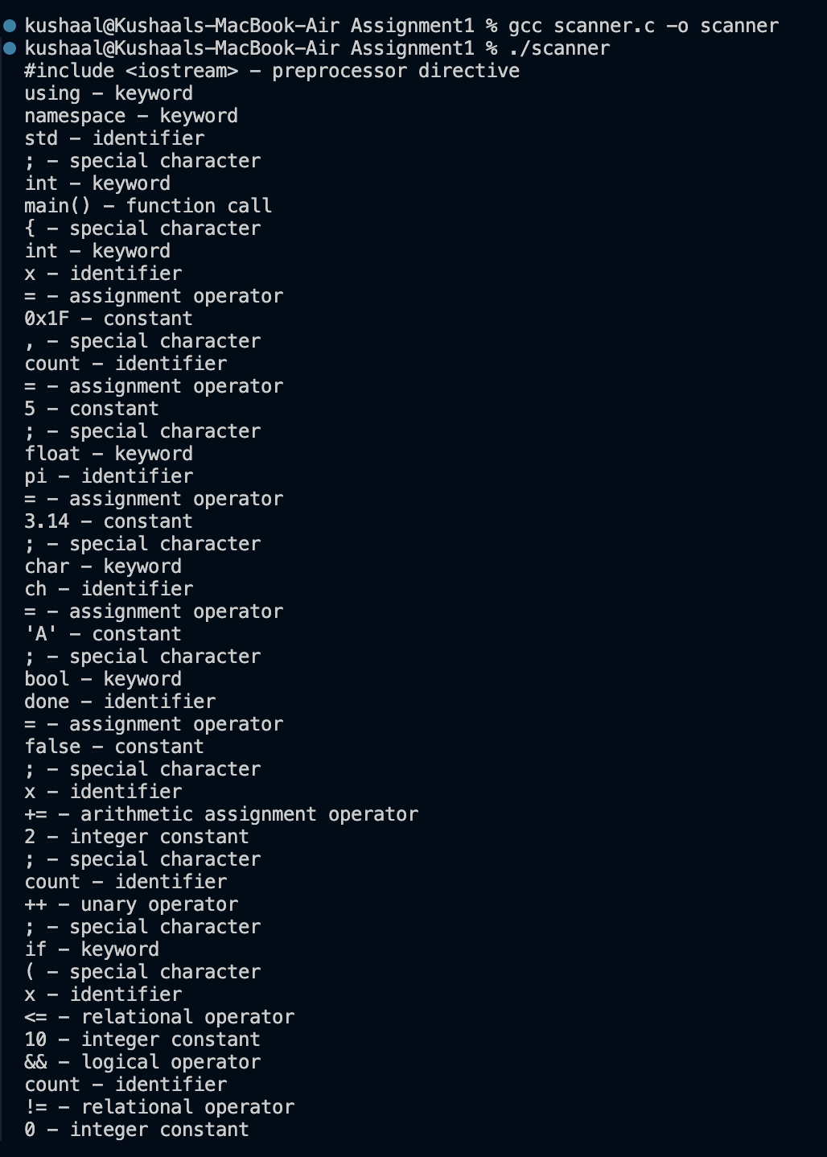

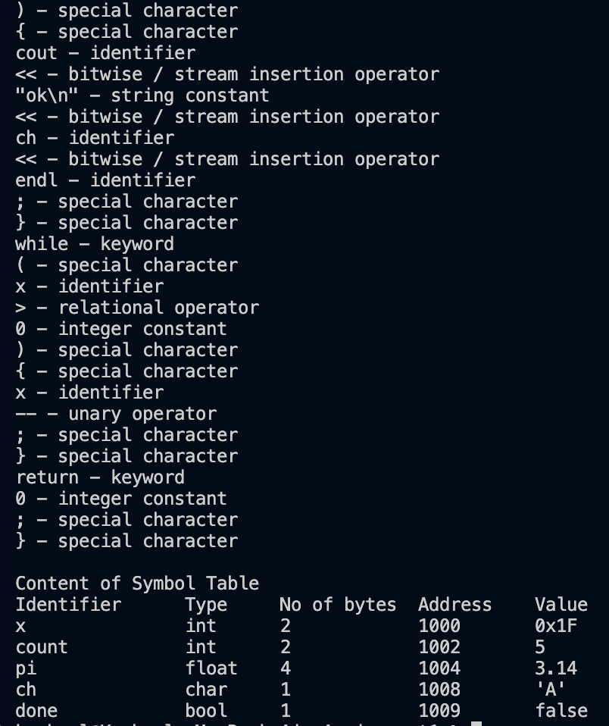
Learning Outcomes:
- Understood that lexical analysis is the first phase of a compiler and what it is responsible for.
- Learned how the different kinds of tokens in a programming language are recognized and classified.
- Learned how to build and maintain a symbol table that stores the attributes of identifiers.
- Got practical experience in detecting lexical errors such as unterminated comments and strings.

